Functionality Specification Document

**Author:** Shruti Priya

**Project Name:** Flyaway

**Contact:** +91 7661802094

1.About the Document

The content of the document will give the solution and configuration details. The platform used for this project is the eclipse IDE, Tomcat, MySQL, Java

2. Objective

The objective of this document is to describe how the FLYAWAY will integrate with end user.

This document also provides information on end to end workflow so that the end user can understand the features and functionality of the FLYAWAY.

1. A Search from in the homepage that allows user to enter travel details like date of travel, source, destination, number of adult.
2. Based on the travel details entered. It will show the available flights with their ticket prices.
3. Once a user selects a flight to book , they will navigate to a login page Where user have to verify their credential.
4. If he/she is not a registered user then , they will navigate to the register page.
5. After registering the credential, user will navigate to the login page.
6. In the next page, they are shown the flight details , user have to enter passengers name, and payment details, etc.
7. On Completion of the dummy payment, they are shown a confirmation page with the details of the flight.

3.Flow Chart

Start

User is asked to enter the booking details like sourse, destination, date of travel, number of passengers

Registered User

End

Booking Confirmation

Dummy Payement

Register

Login Page

Based on the entered booking details the available flights are shown to the user to book

**IF NO**

**YES**

**4.Sprint Planning**

This section explains the how the workload was divided into smaller part and was completed.

It was divided into three parts.

1. Task to do.
2. In Progress.
3. Done.

The timebox for each sprint was 1 WEEK

Sprint 1

1. Design the flight’s details page.
2. Design the admin page.
3. Design the Database and two tables in DB.
4. One table for flight details and other for admin login
5. Design the flight details page.

Sprint 2

1. Design the login page.
2. Design the dummy payment page.
3. Design the register user page.
4. Database table for user login and register page.
5. Design the welcome page that have both flight search and admin login page.
6. Design the confirmation page.
7. Design the ADD flight page.
8. Database table for Add flight page.
9. Design the screen to view all flights.
10. Design the screen to view All airlines.
11. Design the screen that have to option to change password.

**Overview**

First page pf the application

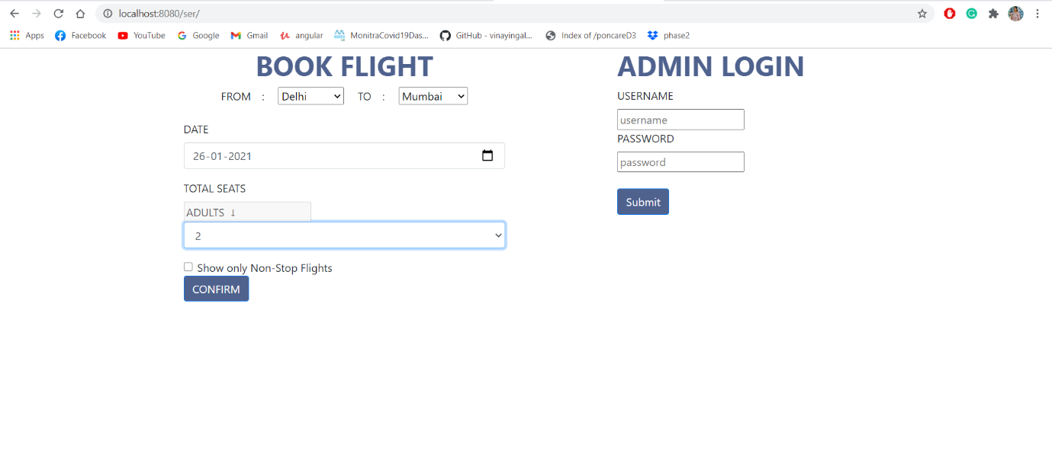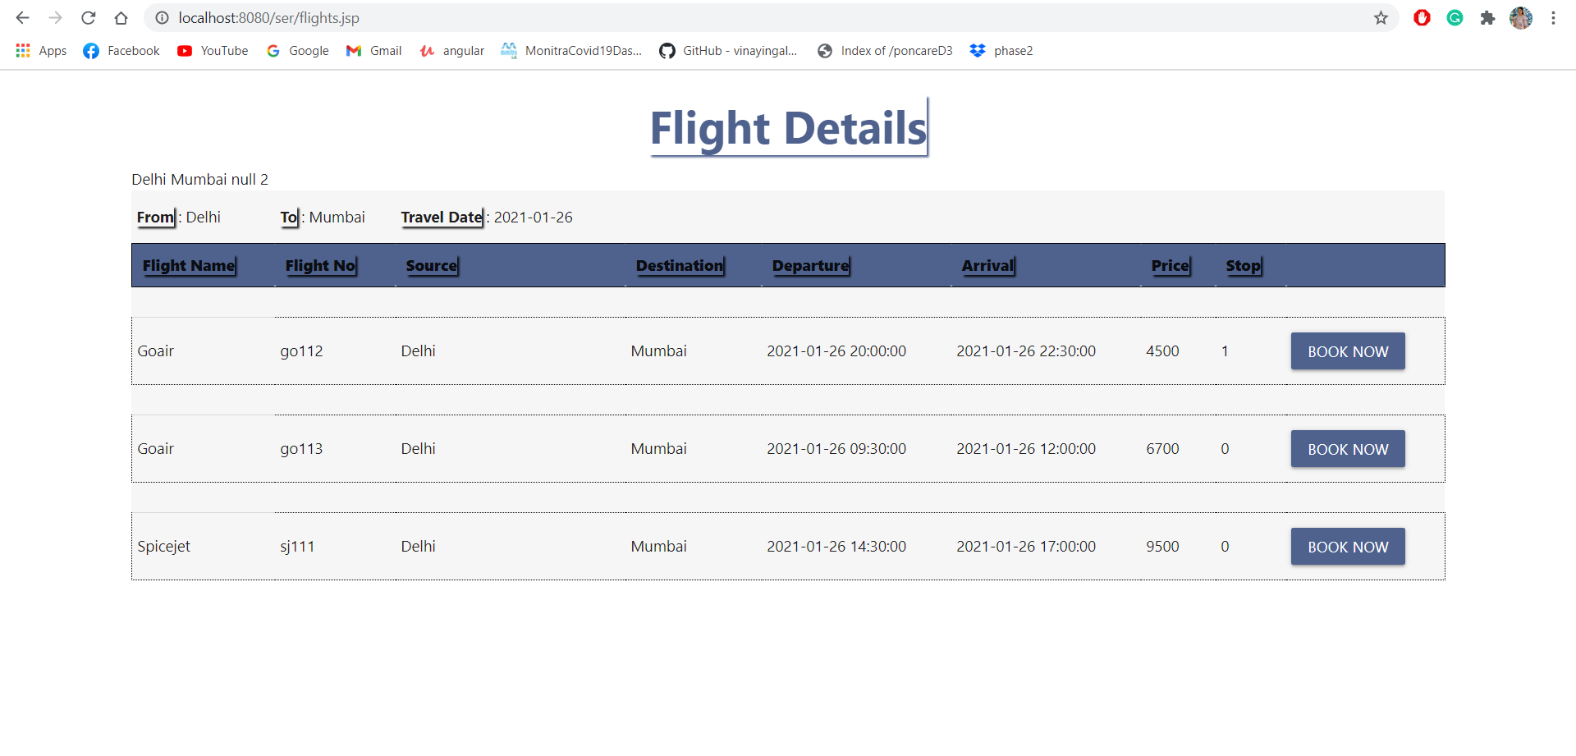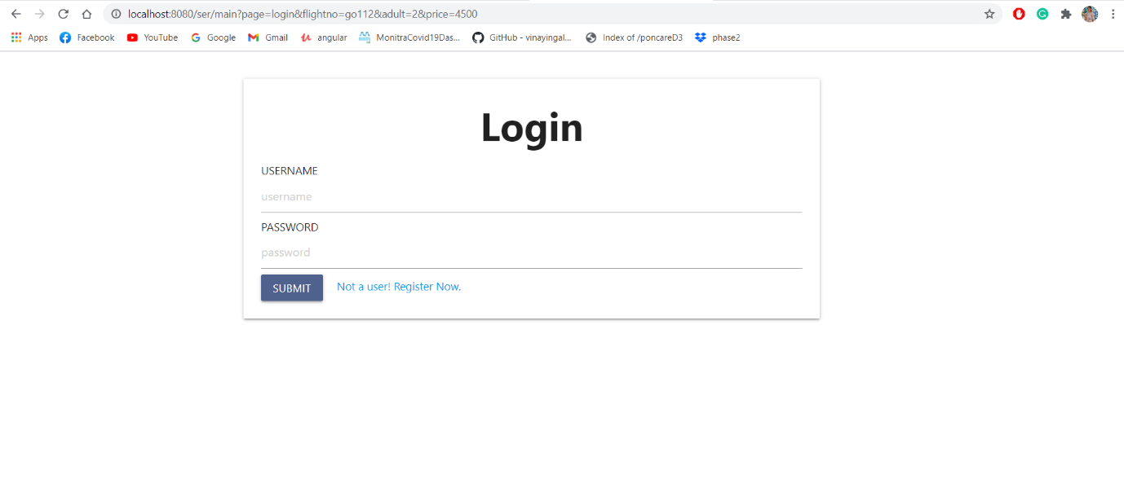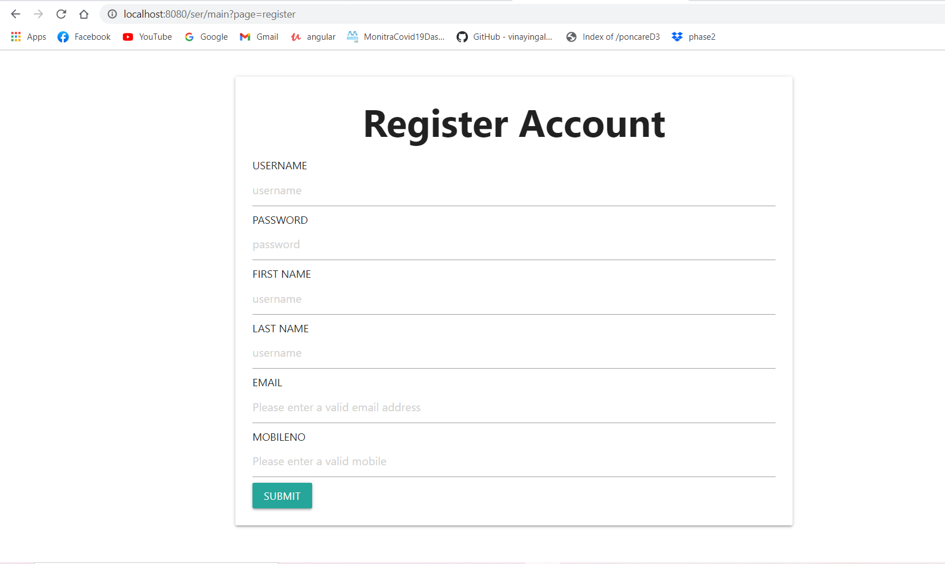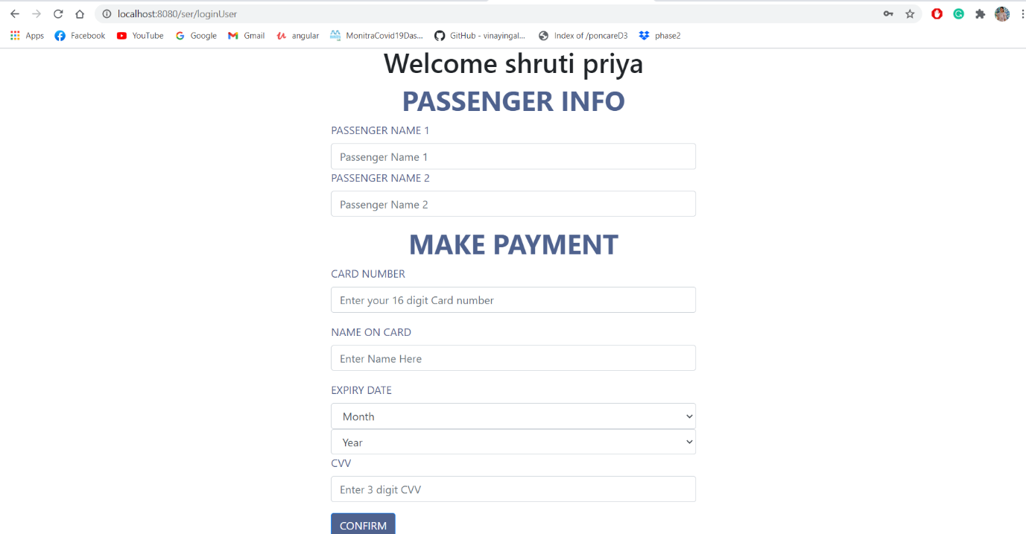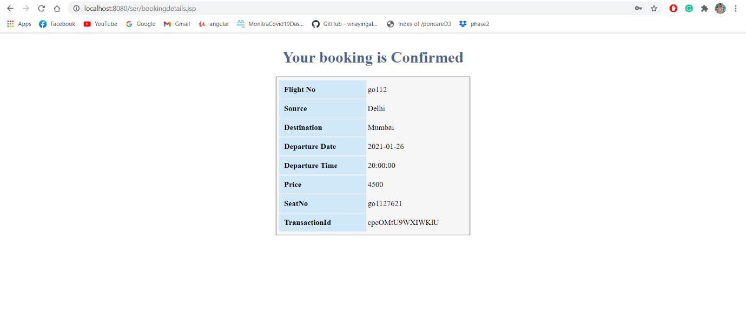

**Admin Login**

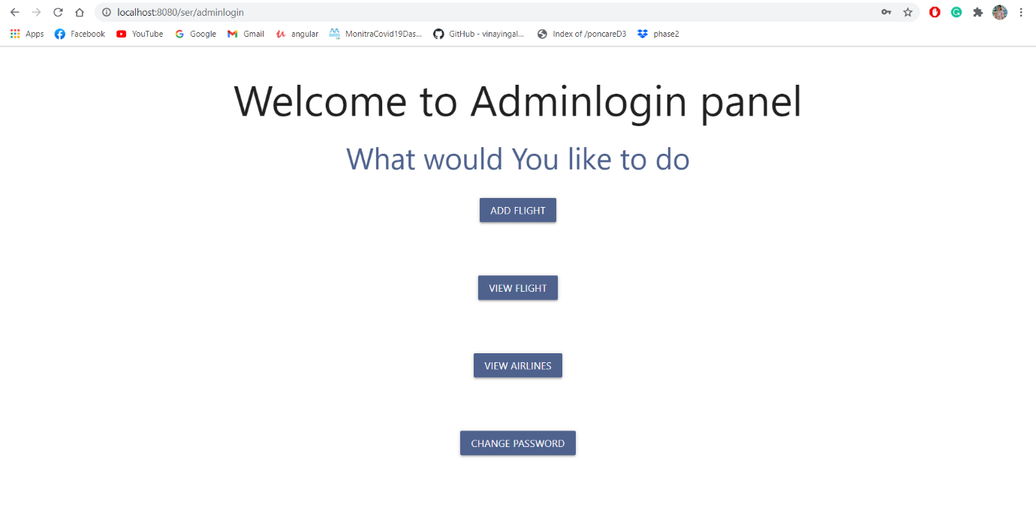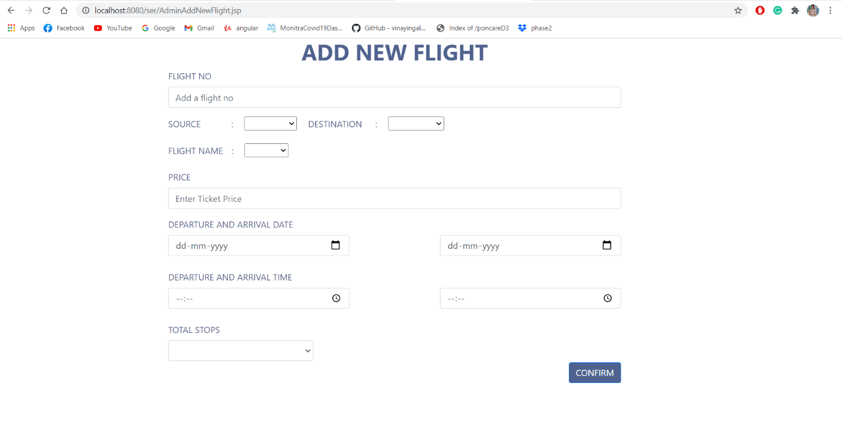

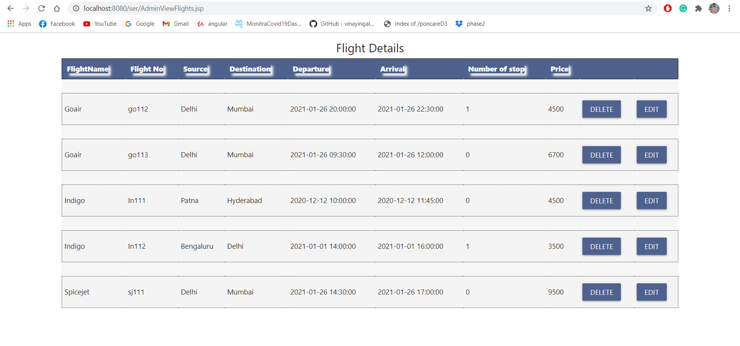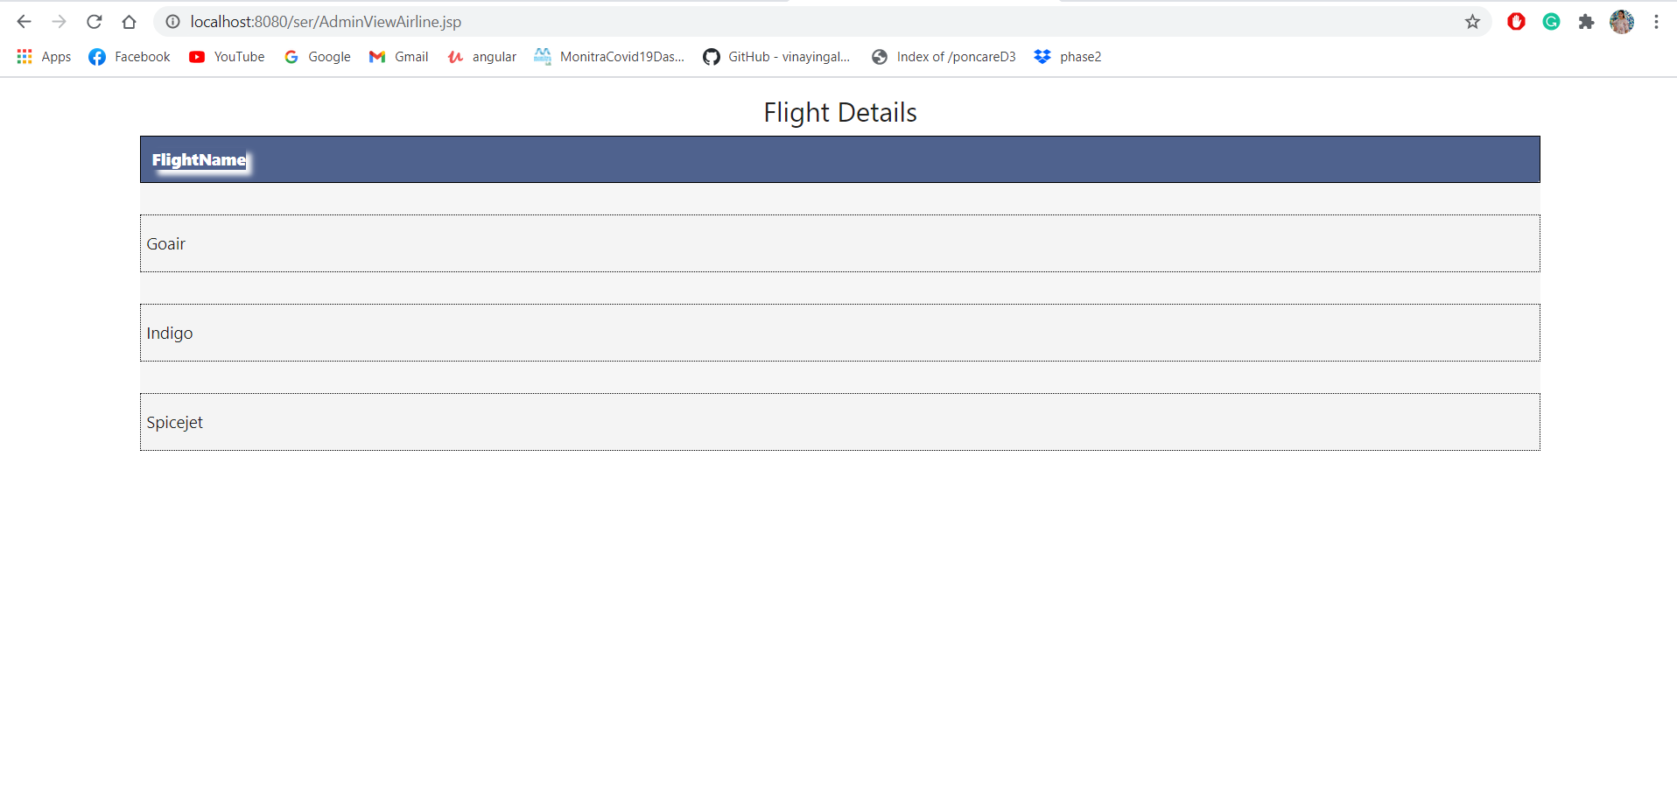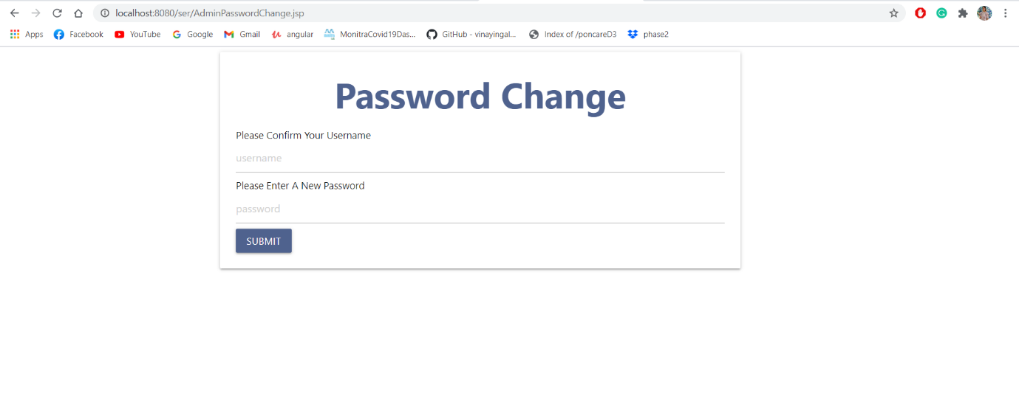

**Database**

There are 4 tables in the DB.

